Week 9: Characters and Stories

## Story arcs

The chosen arc for the team’s story and character building is the ‘Three story arc”. This arc consists of the first act being the “Exposition”, followed by the “Confrontation” as the second act and finally the “Resolution” as ending act.

## Created characters

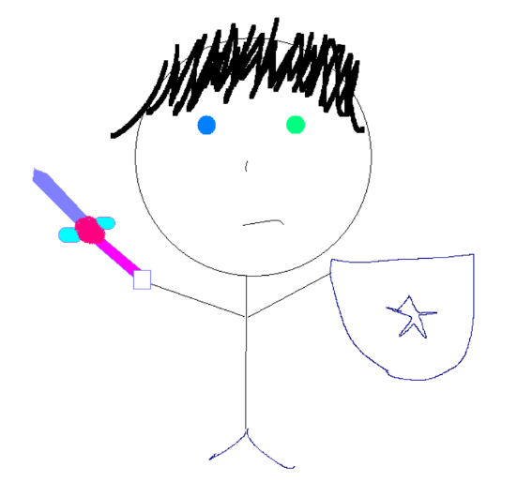

*Figure 1: A sketch of the main character, John Wok*



*Figure 1.1: A sketch of the betrayer, Bill Mill*



*Figure 1.2: A sketch of the main character’s lover, Sophieash*

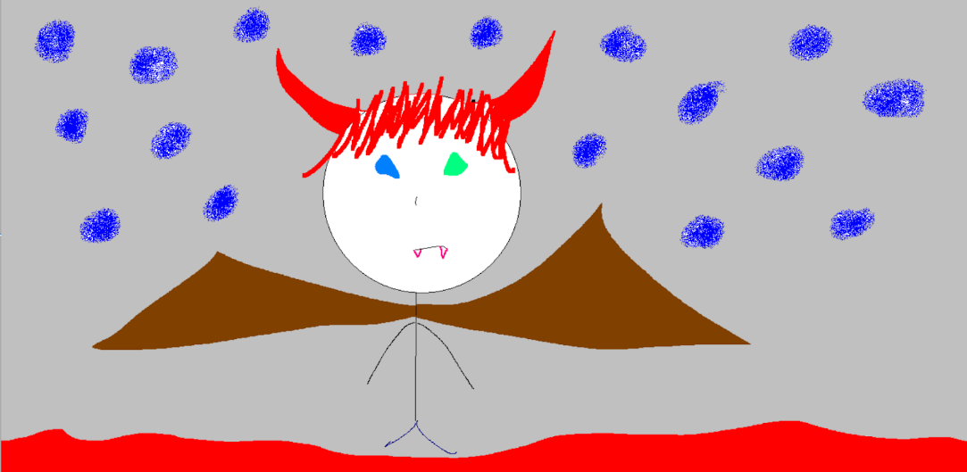

*Figure 1.3: John Wok’s transformation into a demon after he is enraged*

## Chosen details for main character

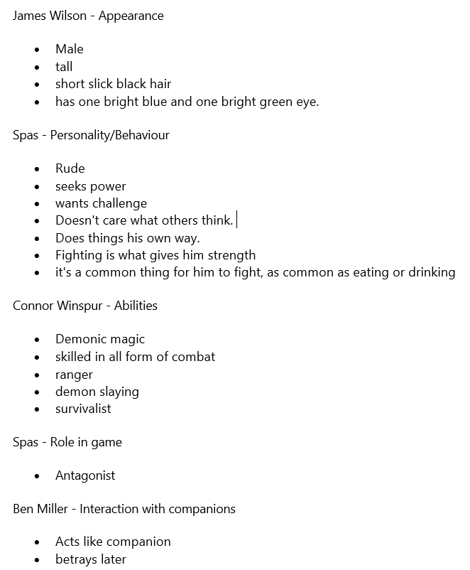

Figure 2: The list above shows the chosen characteristics the main character will have and from whom we took these points from

## Diagram of The Hero’s Journey

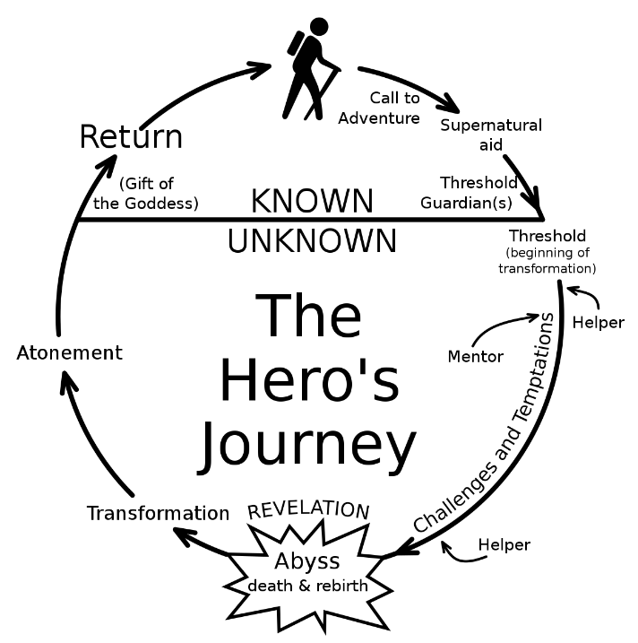

*Figure 3: A diagram illustrating how the story will play out in the team’s recreation of its story*

## A Wok’s Journey

## Call to Adventure

John Wok’s village is destroyed by knights in silver armour. The only survivors are John Wok himself and Bill Mill. They both flee from the village into a nearby forest during the attack in hopes of surviving. A bounty has been put up for John Wok’s head as he inherits ‘demon blood’. He does not know of this fact, but Bill Mill does- as he is the one who issued the attack. Before the death of John Wok’s father, he revealed who John Wok’s ‘real’ father is. Now both of them set off on an adventure to find his real father.

## Supernatural aid

Bill Mill recovers a legendary sword that is found in a ruined cave and bestows it upon John Wok. The sword has since boosted his effectiveness against demons.

## Threshold

John Wok finds his real father. Ever since then, they have been mentor and student; training for what’s to come. His father decides to train his son as he was told of what happened to the village. John Wok is out for revenge. During his journey, John Wok met a girl named Sophieash. However, he took no notice of her as he was too busy gathering power as well as training.

## Abyss (Death and Rebirth)

John Wok is betrayed by his friend Bill Mill, who has been working behind the scenes to get him captured and killed this whole time. During the betrayal, John Wok is stabbed by Bill Mill from the back with a demonic sword. John Wok is left to die in the middle of the capitol. Bill Mill turns and walks away from the body. John Wok, having almost died from blood lost sacrifices his life in exchange for ‘true demonic prowess’. John Wok transforms into a demon with full demon blood. At this stage, he has no sense of who he used to be and is rampaging like a beast.

## Transformation

After the battle at the capitol, he escapes as he has finished what he came to do. Tired and with little life remaining he returns to his village. Looking back at everything, he wishes to rebuild the village once more.

## Atonement

John Wok go head-to-head with Bill Mill in the final battle. Bill Mill has been defeated and the battle is over. John Wok has lost everything- his village, the people, his step-father and now his once-before best friend.

## Return

Once everything has settled, John Wok began rebuilding his village from scratch. This time he is accompanied by the girl he met during his journey; Sophieash. They both fell in love and builds a family with her. This is the story of A Wok’s Journey.

## Implementation into a game

Although it is a three-story arc, the team would want it so that the game can be implemented as a single-player game. With the events created, the team believes that as the game progresses, the players will feel attached to some of the characters and begin to feel how they would feel in that situation. Since there is killing and violence, they game would likely be rated 15+.